Resilient4j implementation

To implement circuit breaker pattern we need to do that in api gate way server and microservices

Add the below dependency in the api gate way server



Then in the api gateway server add circuit breaker filter

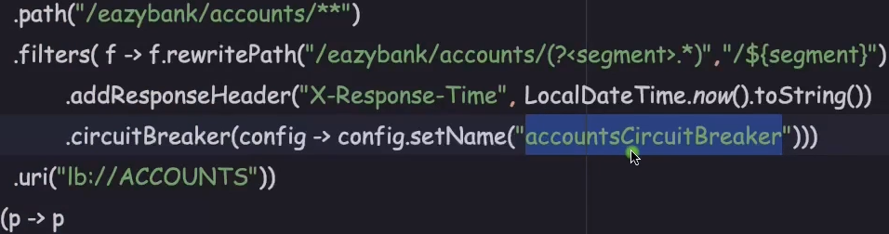

Then add the properties in applidation.properties file

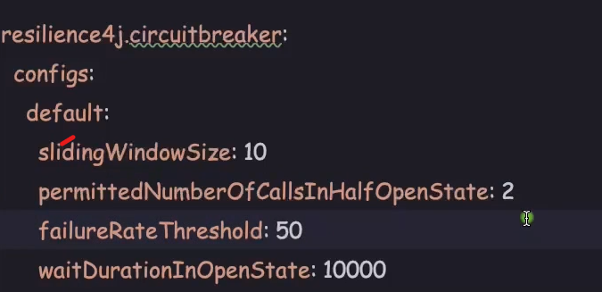

Then start all the services

Config server, eureka server, microservices, gateway server

Fallback mechanism

Create fallback controller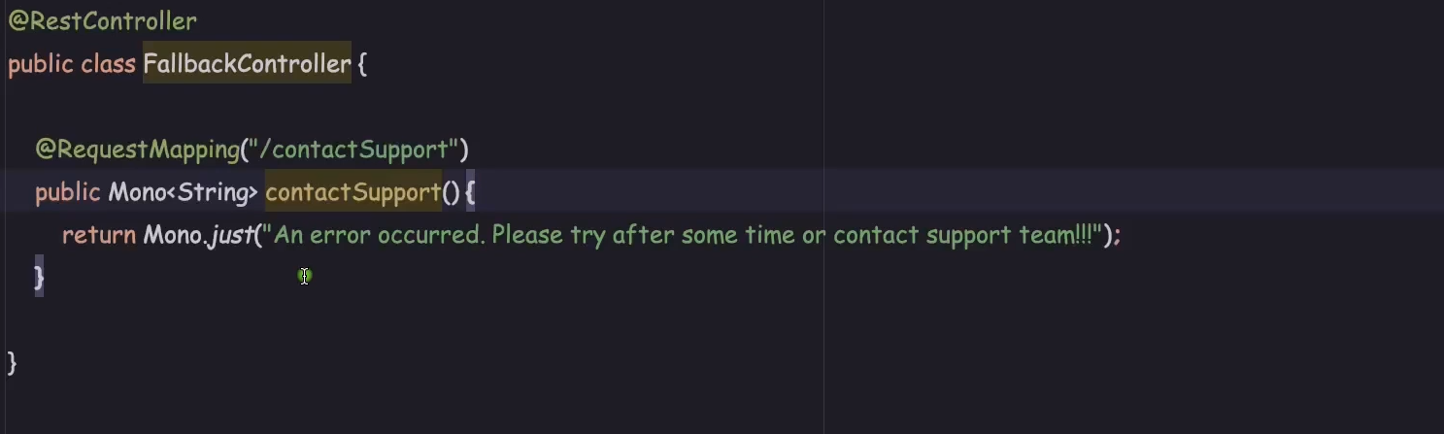

Now add the filter in main application file of gateway server

